SCIENTIFIC TEMPLATE: ALL SAMPLE TEXT, FIGURES, AND DATA MUST BE REPLACED BY THE AUTHOR.
Note to Authors: This article is an informal draft of the author's original work, intended solely as a sample submission for the Journal of Enlightenment Science and Technology (JEST). The original English version can be found at: [link to your original article's URL or DOI].
[STUDY TITLE: Replace this with your full research title]
¹[First-Author], ^{2, *}[Corresponding Author (Usually the mentor)]

¹[First Affiliation, Department/ Institution (if have)], [First Affiliation, School Name], [First Affiliation, City of School], [First Affiliation, Country of School]
²[Second Affiliation, Department/ Institution (if have)], [Second Affiliation, School Name], [Second Affiliation, City of School], [Second Affiliation, Country of School]
*Correspondence: [Email Adress (email@example.com)]

Abstract
[REPLACE WITH YOUR ABSTRACT: Follow the Hook-Problem-Approach-Result-Conclusion structure. Maximum 250 words.]
The development of safe skin-whitening agents is critical for treating hyperpigmentation. However, conventional tyrosinase inhibitors often raise safety concerns, prompting the exploration of alternative regulatory pathways for melanogenesis, such as antioxidant mechanisms. In this study, we evaluated the antioxidant and anti-melanogenic efficacy of ethanol extracts from five medicinal plants. Among the screened candidates, Rubus parvifolius (RP-E), Rhodomyrtus tomentosa (RT-E), and Rosa laevigata (CR-E) exhibited the strongest radical scavenging capacity in both ABTS (IC₅₀$≈$20-30 μg/mL) and DPPH (IC₅₀$≈$50 μg/mL) assays. While all three extracts significantly inhibited melanin synthesis in B16F10 cells stimulated with α-melanocyte-stimulating hormone (α-MSH), only RP-E and RT-E demonstrated dose-dependent inhibition at non-cytotoxic concentrations. Crucially, combinatorial analysis using the Bliss Independence model revealed that 1:1 mixtures of these extracts resulted in antagonistic antioxidant effects and additive cytotoxicity, failing to show synergistic benefits. These findings identify RP-E and RT-E as promising dual-function candidates for skin whitening, while suggesting that optimized single-extract formulations offer superior safety and efficacy profiles compared to crude combinations.
Keywords: [keywords 1], [keywords 2], [keywords 3].
(Note: Your abstract should include a Hook, the Problem, your Approach, key Results, and a Conclusion within 250 words.)

Introduction
[REPLACE WITH YOUR OWN INTRODUCTION: Introduce the background and the specific problem you want to solve. Ensure your unique approach is clearly stated.]
The regulation of skin pigmentation is a complex physiological process primarily driven by melanogenesis, the biochemical synthesis of melanin within the melanosomes of melanocytes. While melanin serves a critical physiological role in protecting the skin from ultraviolet (UV) radiation damage, its overexpression or dysregulation leads to various hyperpigmentary disorders, such as melasma, solar lentigines, and post-inflammatory hyperpigmentation^{1,2}.
Currently, commercial whitening agents like hydroquinone and arbutin are widely employed as competitive inhibitors of tyrosinase, the rate-limiting enzyme in melanin biosynthesis². However, synthetic agents are often associated with cytotoxicity and instability^{3,4}. Consequently, there is a paradigm shift towards identifying biocompatible, plant-derived alternatives^{5,6}.
…
(Note: Briefly introduce the background, the problem you want to solve, and why your approach is unique.)

Results
[REPLACE WITH YOUR RESULTS: Describe your findings objectively. Use subheadings to organize different experiments or logical steps.]
Cytotoxicity Profiling and Dosage Selection
Establishing the safety profile is a prerequisite. Cell viability was assessed using the MTT assay after treatment of B16F10 cells with the extracts (see Materials and Methods). The concentration range was selected from previous test, marked cytotoxicity was observed in each extract (except IA-E) when concentration at concentrations above 100 μg/mL (Fig. S1). Cytotoxicity profiling was conducted within a narrow concentration range (Fig. 1A). CR-E was highly cytotoxic, with significant viability dropping at concentrations > 20 μg/mL. In contrast, FE-E exhibited an excellent safety profile up to 50 μg/mL. RP-E and RT-E maintained > 80% viability up to 30-40 μg/mL. Furthermore, we picked the data and compared these five extracts at the same concentration 50 μg/mL condition, demonstrating comparative safety profiles across the extracts (Fig. 1B). Consequently, functional assays were restricted to these non-lethal dosages to exclude false positives caused by cell death. This step ensured that subsequent anti-melanogenic effects were not secondary to cytotoxicity.

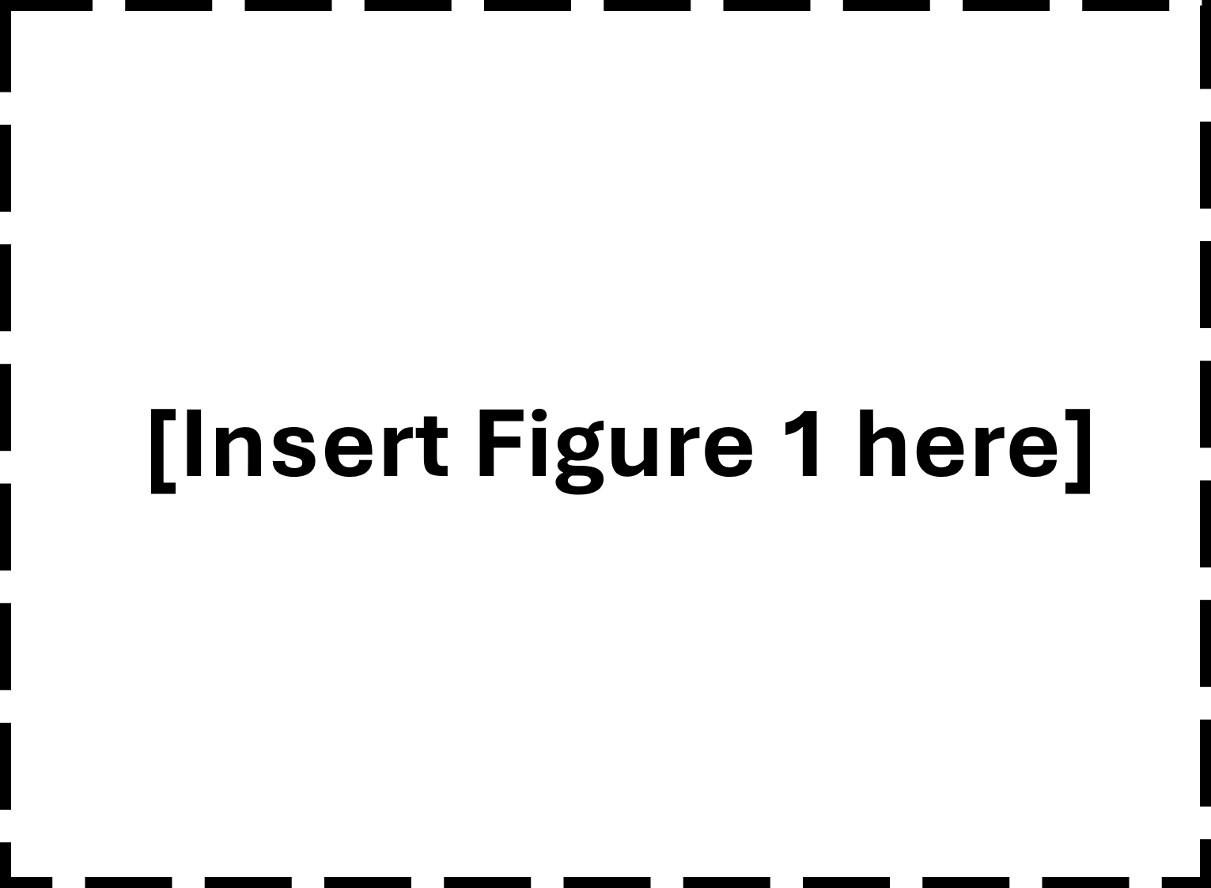
Fig 1. Dose-dependent cytotoxicity and comparative safety of five medicinal plant extracts. (A) Botanical extracts display discrepant cytotoxicity in B16F10 cells. (B) With the comparison between different botanical extracts at 50 μg/mL concentration.
Statistical analysis was performed using One-way ANOVA followed by Dunnett’s multiple comparisons test (A) or Tukey’s multiple comparisons test (B). Statistical significance was defined as *p < 0.05, **p < 0.01, ***p < 0.001, and ****p < 0.0001 compared to the control or indicated groups.

Antioxidant Efficacy
Extracts were screened for their ability to neutralize free radicals, a key mechanism in suppressing melanogenesis signaling ^{7–9}.
Assessment of the dose-response relationships using the extra sum-of-squares F test confirmed that the antioxidant profiles of the five extracts were significantly different in both assays (DPPH: F(8, 80) = 116.8, p < 0.0001; ABTS: F(8, 106) = 61.6, p < 0.0001), indicating distinct bioactivities.
…
[RESULTS SUBHEADING: Replace with a descriptive title of your first key finding].
[OPTIONAL: For Computer Science or Math, you may include Pseudo-code or Theorems here if they are central to your results.]

Discussion
[REPLACE WITH YOUR OWN DISCUSSION: Interpret your results and compare them with existing literature. Do not just repeat the results.]
ROS Scavenging and Depigmentation
Our data reveals a distinct correlation: extracts with high antioxidant capacity (RP-E and RT-E) consistently inhibited melanin synthesis. While CR-E showed a similar effect on inhibiting melanin content, the significant decrease in cell viability implied that cytotoxicity might contribute to the observed inhibitory effect. The correlation model suggests that these extracts might function by quenching intracellular ROS. Since ROS are essential secondary messengers in the α-MSH/cAMP/PKA signaling cascade, their depletion effectively downregulates downstream MITF expression, preventing tyrosinase activation^{5,7,10,11}. As demonstrated in our results, RT-E and RP-E exhibit potent radical scavenging activities that correlate strongly with their depigmenting efficacy. Therefore, we postulate that these extracts function by eliminating the oxidative stress required for signaling propagation, effectively placing a "brake" on MITF transcription, rather than solely acting as direct enzyme inhibitors. This "antioxidant-dependent depigmentation" is a safer strategy ^{5,12}, in contrast to conventional synthetic tyrosinase inhibitors, which have been reported to exhibit higher toxicity profiles ^{3,4}.
…
(Note: Do not just repeat results. Explain "why" it happened and how it compares to previous studies.)

Materials and Methods
[REPLACE WITH YOUR OWN METHODS: Describe your experimental procedures, materials, or logical frameworks. Provide enough detail for replication.]
Plant Materials and Extraction Procedure
The roots and stems of IA, CR, RP, and RT, and the leaves of FE were dried and pulverized. Extraction was performed using 95% ethanol at a solid-to-solvent ratio of 1:10 (w/v) for 48 hours. The supernatant was filtered, concentrated via rotary evaporation under reduced pressure (50–60°C, 50–140 mmHg; [Company Name and Product Number]), and lyophilized to obtain crude extract powders. The powder was then dissolved in dimethyl sulfoxide (DMSO; [Company Name and Product Number]).
…
[METHODOLOGY: e.g., Experimental Setup / Theoretical Framework / Data Acquisition].

Conclusion
[REPLACE WITH YOUR OWN CONCLUSION: Summarize your key findings and their impact. State your final hierarchy or efficacy results.]
This study identifies Rhodomyrtus tomentosa (RT-E) and Rubus parvifolius (RP-E) as superior skin-whitening candidates, primarily driven by their potent antioxidant capacity (IC₅₀ $≈$ 20 μg/mL). The efficacy hierarchy is RT-E $≈$ RP-E > CR-E $≫$ FE-E > IA-E. Crucially, we demonstrate that simply combining crude extracts can lead to additive toxicity, negating the benefits of efficacy synergy. Future applications should focus on refined fractions of RT-E and RP-E to maximize safety and efficacy.
…

Acknowledgments
We would like to thank [Name of Mentor/Teacher] for their guidance and [School Name] for providing the laboratory facilities.

Author Contributions
[Initials]: Conceptualization, Investigation, and Writing – original draft. [Initials]: Data curation and Formal analysis.

Data Availability
The data that support the findings of this study are available from the corresponding author upon reasonable request.

Conflict of Interest
The authors declare no competing financial or personal interests.

Ethics Approval
Not applicable. This research does not involve human subjects or vertebrate animal models.

Declaration of Generative AI
During the preparation of this work, the authors used [Tool Name] for [e.g., grammar checking/language polishing]. The authors take full responsibility for the integrity of the final content.

References
[REPLACE WITH YOUR OWN REFERENCES: List all sources cited in your text in the order they appear. Ensure every number in the text matches a source here. Delete all sample references below before submission.]
- Author, A. B. & Author, C. D. Title of the sample research article. Journal of Enlightenment Science & Technology 1, 100–105 (2026). https://doi.org/10.xxxx/xxxxxx
…

English reference format: Author, A. B. Title of the paper. Journal Name Volume, Page–Page (Year). DOI link
Chinese reference format: Author, A. B. Title of the paper in English. Journal Name in English/Pinyin Volume, Page–Page (Year). (in Chinese)。DOI連結

Supplementary Material
[REPLACE WITH YOUR OWN SUPPLEMENTARY DATA: Include raw data, code, or additional photos that support your main text.]
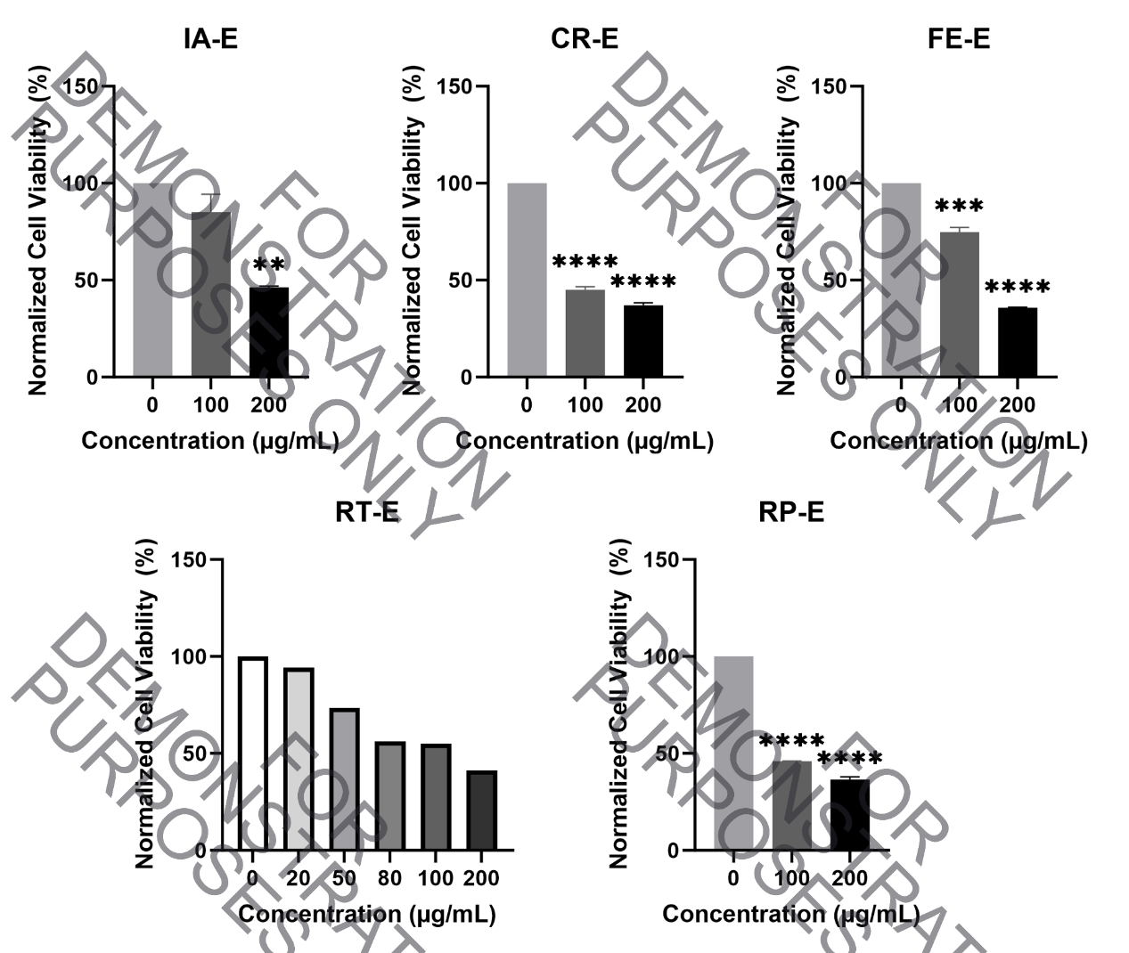
Fig S1. Preliminary Cytotoxicity Screening (Broad Range). B16F10 cells were treated with extracts from 0 to 200 μg/mL (N=2, and N=1 with RT-E). This pre-test data was utilized to determine the safe working concentrations for subsequent functional assays (restricted to non-lethal doses shown in Fig. 1). Statistical analysis was performed using One-way ANOVA followed by Dunnett’s multiple comparisons test. Statistical significance was defined as *p < 0.05, **p < 0.01, ***p < 0.001, and ****p < 0.0001 compared to the control or between indicated groups.

Appendix: Formatting Guidelines for Figures, Tables, and Equations
Figures
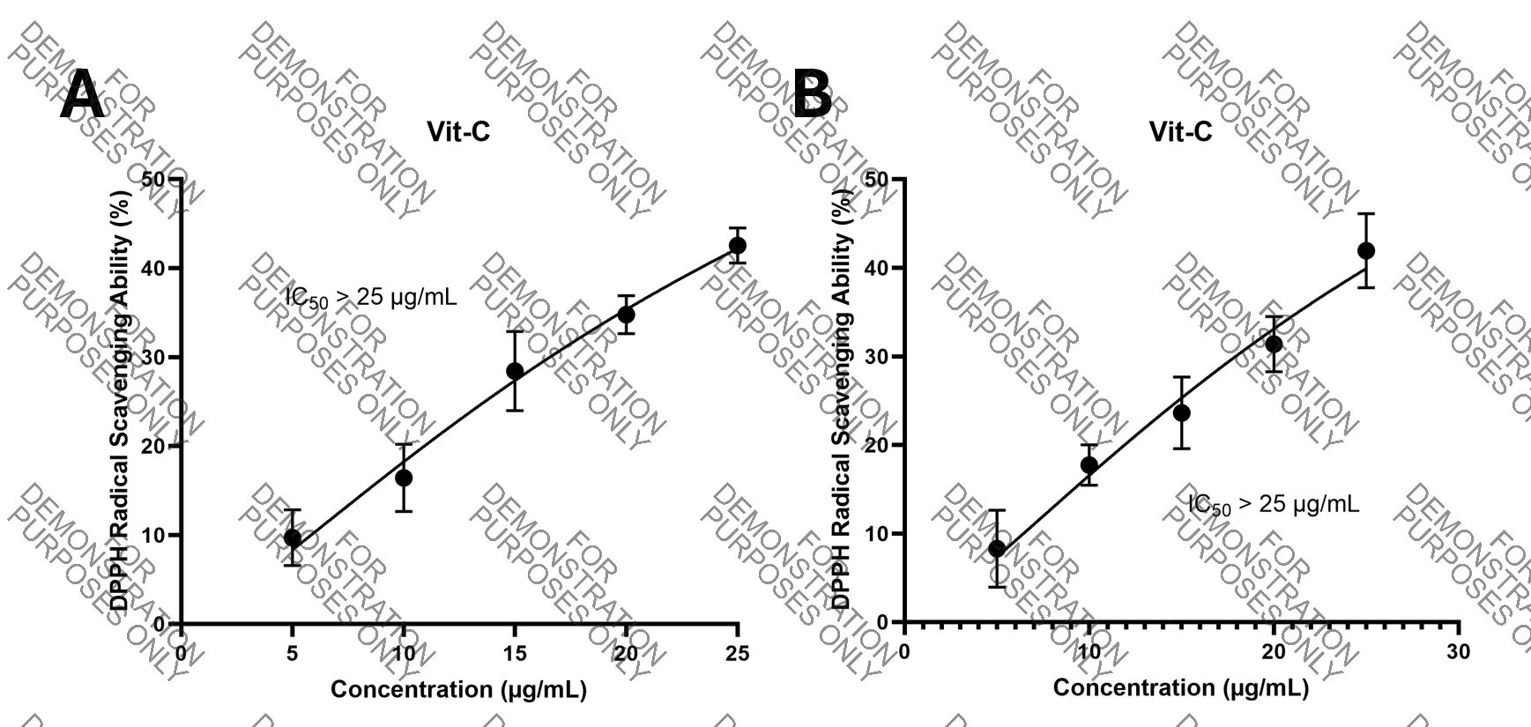
Fig 1. [Title]. (A) [Description of panel A]. (B) [Description of panel B]. Data are presented as mean ± SD (N=3).

(Note: Please ensure images are high resolution, at least 300 dpi）

Tables
Table 1. Summary of [Subject].
Sample | DPPH IC₅₀ (μg/mL) | AVTS IC₅₀ (μg/mL)
Control | 24.2 ± 1.2 | 12.5 ± 0.8
A Material | 48.6 ± 2.3 | 21.4 ± 1.5
B Material | 52.1 ± 3.1 | 25.8 ± 2.1
C Material | 55.4 ± 2.8 | 30.2 ± 1.9
Control: …; A Material: …; …

Table Formatting Guidelines:
1. Title: Placed above the table.
2. Lines: Use only three horizontal lines (top, bottom, and header separation). No vertical lines.
3. Abbreviations: Define any abbreviations used in the table (e.g., RP-E: Rubus parvifolius ethanol extract) in a footnote below the table.

Equations
$DPPH Scavenging Activity \left(\%\right)=\frac{A_{control}-A_{sample}}{A_{control}}×100\%$ (1)

Statistical Significance
Always define your p-values in the figure legend.
Correct: *p < 0.05, **p < 0.01.
Incorrect: p = 0.0432 (Unless specifically required).

Units and Measurements
Use SI units. Note the space between the number and the unit.
Correct: 50 μg/mL, 37°C, 10 min.
Incorrect: 50ug/ml, 37 C, 10min.

Appendix: Final Submission Checklist
Anonymization (Double-Blind Review):
[ ] Remove all author names, school names, and teacher names from the manuscript.
[ ] Ensure the "Acknowledgments" section does not reveal your identity (save these for the Title Page).

Abstract & Keywords:
[ ] Abstract is within 250 words and follows the Hook-Problem-Approach-Result-Conclusion structure.
[ ] Include 3-5 specific keywords.

Figures & Tables:
[ ] Figures are high resolution (minimum 300 dpi).
[ ] Tables use the "Three-Line" format (top, header-bottom, and bottom lines only).
[ ] All figures and tables are cited in the text (e.g., "see Fig. 1").

Equations & Units:
[ ] Equations are centered with right-aligned numbers in parentheses.
[ ] Use SI units with a space between the number and the unit (e.g., 10 μg/mL).
Statistical Significance:
[ ] Define all p-values in the figure/table legends (e.g., *p < 0.05).

References:
[ ] Use numbered citations in order of appearance (e.g., 1, 2, 3...).

